**Setting working directory manually**

1. Click on option icon.

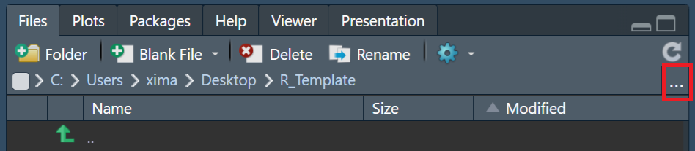

1. Locate your layer 0 folder and click open.



1. Click on gear icon.

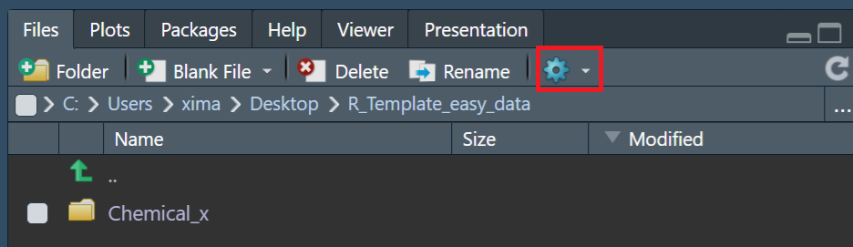

1. Click “Set As Working Directory”.

